**NATIONAL UNIVERSITY OF COMPUTER AND**

**EMERGING SCIENCES**

**SL-2002 – Software Design & Architecture Lab**

**Lab Instructor: Zarnain Maryam Awan**

**Lab 06**

**Activity Diagram:**

An activity diagram is a type of UML (Unified Modeling Language) diagram that visually represents the flow of activities or actions within a system or process. It is commonly used in software engineering and business process modeling to describe the sequential and parallel activities involved in accomplishing a specific task or process.

Activity diagrams consist of various elements that represent different aspects of the process:

1. **Activities:** Represent specific actions or tasks that occur within the process. These activities are depicted as rounded rectangles.
2. **Transitions:** Represent the flow of control from one activity to another. They are depicted as arrows connecting the activities and indicate the direction of flow.
3. **Decision Points**: Represent points in the process where different actions or paths may be taken based on certain conditions. They are depicted as diamonds and are often labeled with the decision that needs to be made.
4. **Start and End Points:** Represent the beginning and end of the process respectively. They are typically depicted as circles and labeled with "Start" and "End".
5. **Forks and Joins:** Represent parallel activities or concurrent execution of tasks. Forks split the flow into multiple parallel paths, while joins bring these paths back together.
6. **Swimlanes:** Optionally used to organize activities based on the responsible entity, such as departments or actors.

Activity diagrams help stakeholders understand the workflow of a system or process, identify potential bottlenecks, visualize decision points, and communicate complex processes in a clear and structured manner. They are widely used during the analysis, design, and documentation phases of software development projects, as well as in business process improvement initiatives.

**Activity Diagram Symbols:**

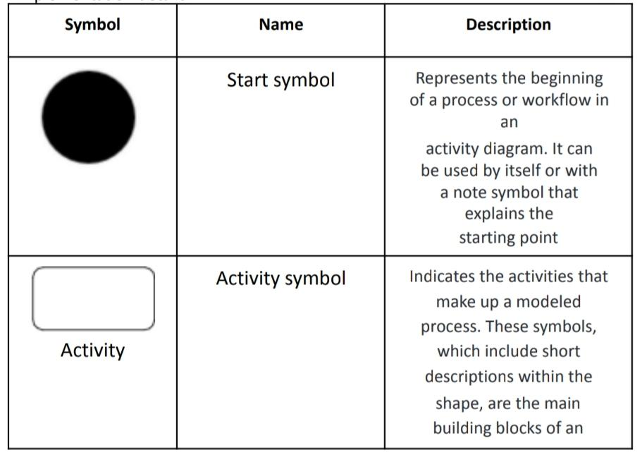

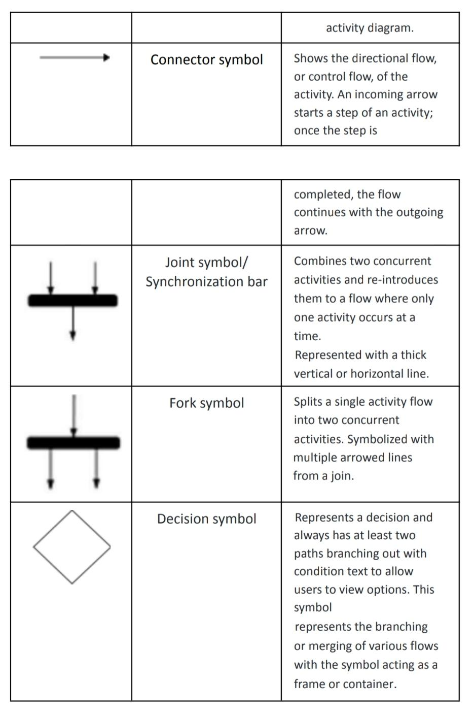

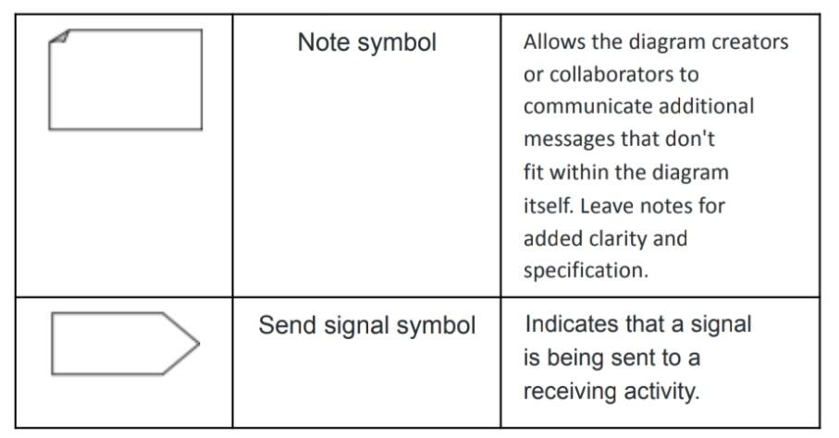

**Steps For Creating Activity Diagram:**

1. Identify Actors: Determine the actors involved in the usecase/scenario. These could be users, external systems, or other entities interacting with the system.
2. Identify Activities: List all the activities or steps involved in the usecase/scenario. These should represent the actions taken by the actors or the system.
3. Draw Start and End Points: Draw the starting point and ending point of the process. Usually, the starting point is triggered by an external event, and the ending point is the completion of the process or achievement of the goal.
4. Draw Initial Diagram Structure: Use a tool or paper to sketch out the initial structure of the activity diagram. Place the starting point at the top and the ending point at the bottom. Draw boxes for each activity and connect them with arrows to represent the flow of activities.
5. Refine the Diagram: Use decision points (diamond shapes) to represent conditions that determine the flow of the process.
6. Add Swimlanes (Optional): If multiple actors or roles are involved, you can use swimlanes to organize activities by actor. This helps clarify responsibilities and interactions between different actors.
7. Review and Validate: Review the diagram to ensure it accurately represents the usecase/scenario and all necessary activities. Validate the diagram with stakeholders or subject matter experts to ensure it aligns with their understanding of the usecase/scenario.
8. Finalize the Diagram: Once validated, finalize the activity diagram by adding any additional comments necessary for understanding. Ensure that the diagram is clear, concise, and easy to follow.
9. Document and Share: Document the activity diagram according to your organization's standards and share it with relevant stakeholders. It should serve as a useful reference for understanding and analyzing the usecase/scenario.

**Let’s take an example;**

**Use Case Name:** Create A Document

**Actors:** User

**Basic Flow Of Events:**

1. Open the word processing package.
2. Create a file.
3. Save the file under a unique name.
4. Type the document.
5. If graphics are necessary, open the graphics package
6. If a spreadsheet is necessary, open the spreadsheet package
7. Save the file.
8. Print a hard copy of the document.
9. Exit office suite

**Alternative Flows:** None

